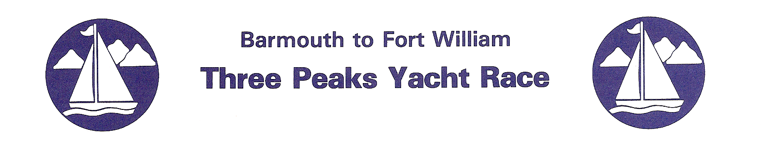
The 39th Three Peaks Yacht Race Starts Next Saturday

The annual Three Peaks Yacht Race takes place from June 11th starting in Barmouth, where 17 adventurous teams will gather to tackle one of the world’s oldest and most prestigious adventure races.

The race is now in its 39th year, and was inspired by the climbing and sailing exploits of Barmouth resident Major H.W. Tilman. This unique event takes combined teams of runners and sailors up the beautiful and treacherous West Coast to Fort William, with the runners going ashore along the way to scale the highest peaks in Wales, England and Scotland.

The sailing distance is around 389 miles and the hazards of the passage include sand bars, the passage of the rocky Menai Strait, numerous tidal gates, and shallow harbour entrances, and there is even a whirlpool to beware of! It is demanding coastal sailing to challenge any skipper and crew and the weather could be anything from gales to calms, during which teams man the oars. It is often both during the race!

For the runners the challenge is to run up and down Snowdon, Scafell Pike and Ben Nevis from the coast. They will be on the mountains in the dark some of the time and will cover 72 miles of running and 14,000 feet of climbing, plus 26 miles of cycling in the Lake District. They may also have to row a yacht, learn to sail and cope with seasickness and a lack of sleep before they even set foot on land!

The race has attracted some of the most famous names in British sailing and mountain running in the past and is on the bucket list for any keen outdoor sportsman. It always attracts an entry from very mixed backgrounds and this year is no exception. The teams have a spirit of adventure and a determination to complete the famous 3 Peaks Yacht Race, but are of all ages, nationalities and sporting backgrounds.

This year’s teams include an all female team, ‘Aparito Digital Health’, who are sailing a J120 and skippered by experienced ocean sailor Pip Hare. Pip is a past winner of the race (in 2013) and her team’s experience includes; rowing the Indian and Atlantic Oceans, deep sea diving on the Titanic and ultra endurance runs around the world.

Another notable female competitor is Dee Caffari, one of Britain’s most successful and best known ocean sailors who has completed 5 Round the World trips. She is skipper on the ‘Sail 4 Cancer Charity’ boat and is joined by Libby Greenhalgh who is the Meteorologist to the British Olympic sailing team.

There are several familiar names among the yachts and competitors (it’s a very addictive race), including multiple race winner Geoff West on his X99, sailing as Wight Rose. His team includes Alex Pilkington who won the ‘King of the Mountains’ title racing with West last year, and he is joined on the runs this time by Czech ultra endurance athlete Pavel Paloncy who recently completed the 8 day 400km Cape Wrath Ultra.

The race may be 39 years old but is still innovating and for the first time this year the overall winner will be decided using IRC Handicap for the sea leg times and it will be fascinating to see how this affects the tactics and results.

Ahead of their return next year the race has also allowed the entry of a multihull, a 26 foot trimaran sailing non-competitively as ‘ABF – The Soldiers’ Charity’. The team of 4 are all army personnel and they plan to all ascend Ben Nevis to complete the race.

Most of the teams are raising money for the charity of their choice and some will have family and friends acting as support crew along the way.

During the race there will be live website updates with satellite tracking of the yachts and runners and daily photos and reports. The race will also be filmed by Dream Team TV for global distribution.

You can find out more about the race and the teams and follow the race live at www.threepeaksyachtrace.co.uk.

You can also follow the race on Facebook at https://www.facebook.com/pages/Barmouth-to-Fort-William-Three-Peaks-Yacht-Race/107471789373349 and on Twitter @3peaksyacht and #3peaksyachtrace.

For more information on the race please contact the press officer by email on info@threepeaksyachtrace.co.uk

The Barmouth to Fort William Three Peaks Yacht Race
A Company Limited by Guarantee. Registered in Wales No: 3722800
Registered Office: Llwyn March, Dyffryn Ardudwy LL442EH
e-mail:secretary@threepeaksyachtrace.co.uk Web Site www.threepeaksyachtrace.co.uk

