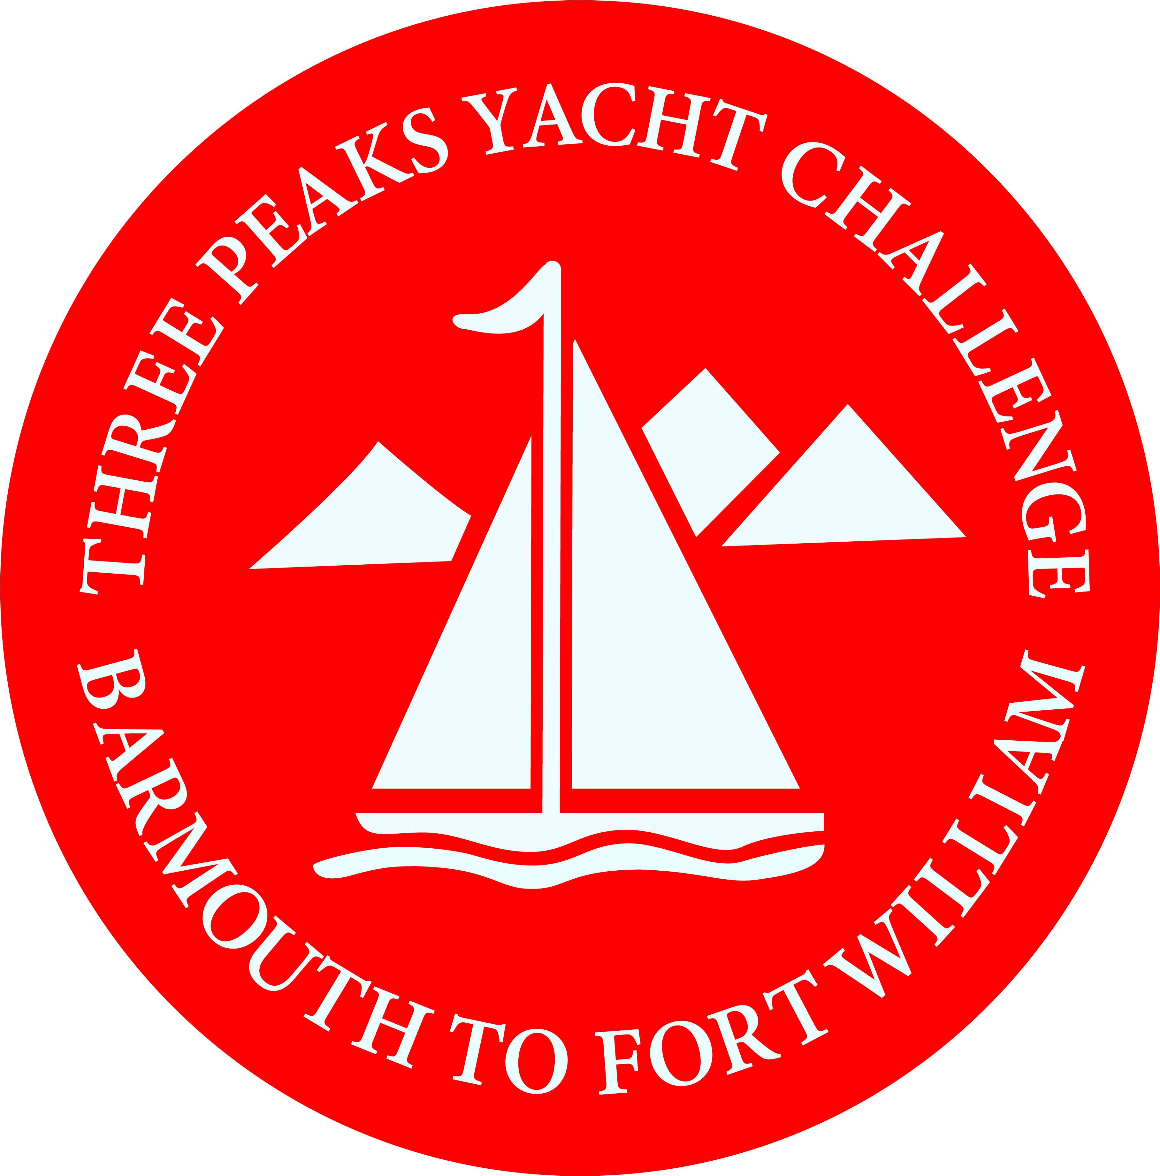
BARMOUTH TO FORT WILLIAM
THREE PEAKS CHALLENGE

ENTRY FORM 2022

I wish to enter The Three Peaks Yacht Challenge starting July 9th 2022.

I agree to abide by the rules of The Challenge including instructions as laid down by the organising committee. I agree that the decision of the Protest Panel appointed by the committee shall be final with respect to all matters concerning The Challenge.

I further agree that I accept all risks associated with participating in The Challenge, also that the committee and/or all members of The Challenge organisation have no liability whatsoever in respect of any loss or damage of any kind, howsoever caused, arising from my participation.

I also agree that only persons who accept the aforementioned risks shall be members of the crew of the yacht entered in The Challenge and that I shall only accept them as crew members after they have signed the appropriate form to this effect.

I am aware that some members of the team will climb the highest mountains in Wales, England, and Scotland.

I affirm that the details given in the entry form are correct, and that if they change I will at once inform the Secretary of the committee. I also affirm that the yacht will be covered by at least third party insurance from the time of arrival at Barmouth until the yacht completes or retires from The Challenge.

Signed: …………………………………… Date: ……………

NAME AND ADDRESS: (In Block Capitals)

……………………………………………………………………………………………………………………….

………………………………………………………………………………………………………………………

………………………………………………………………… POST CODE ………………………………..

Phone No: ………………… Mobile No: ……………

E.MAIL ADDRESS: ……………………………………………………………………………

TEAM NAME: …………………………………………………………………………..
DETAILS OF YACHT

Name of Yacht:

Type of Yacht:

Colour of hull:

Colour of Sail:

Type of Rig:

Sail Number:

Dimensions: LOA……………. Beam………………. Draught………………..

Type of Keel: ……………

Type of Engine: ……………… H.P………………………..

Number of crew (at discretion of the Skipper): ………

Name of Skipper: ……………………………………

Home Port of Yacht: ………………………………..

Other information (e.g. club team, service team, company team, ladies team etc.)

How did you hear of the challenge…………….....
(We are keen to know re. future planning)

Name & address of owner (if different):

PAYMENT

Please return the completed entry form and a cheque for the entry fee of £850 made out to Three Peaks Yacht Race to;

The Secretary Three Peaks Yacht Race
c/o The Merioneth Yacht Club
The Quay
Barmouth
Gwynedd
LL42 1HB

Or

BACS Payment can be made to the Three Peaks Yacht Race Bank Account:-
Sort Code – 52 30 32 – Account - 14025442

